(Approx. 314 words)

Yes! I am a bit old school!
By Joe Isaac, Tech Talk, Central Kentucky Computer Society
July 2018 issue, CKCS Newsletter
www.ckcs.org
joeisaac1234 (at) gmail.com

My daughter wanted to delete some old programs and get them off her computer, but she couldn’t remember how. As is typical of my family members, if they can’t remember how something is done, it becomes my job to solve the problem. Could it be because I taught Windows at CKCS for about 21 years?

Windows 10 is a great program, but the “techies” changed many things when they wrote the new program and then again, they do the regular updates. I knew how to solve her problem easily before Windows 10 – you just go to the “Control Panel”. But that is something I hadn’t seen for a while. I figured a way to get to it using RUN and the old DOS commands but thought there must be a better simpler way. Well, there is.

All you need to do is type CONTROL PANEL in the search bar on the desktop, or ask Cortana to do that for you, and bingo, there is the old control panel, including PROGRAMS AND FEATURES. Another member called and asked where to go to delete his old printer that had died, and they took to the recycle center. Going to the control panel there it is, under DEVICES AND PRINTERS. Just delete the old printer and select another as the default printer.
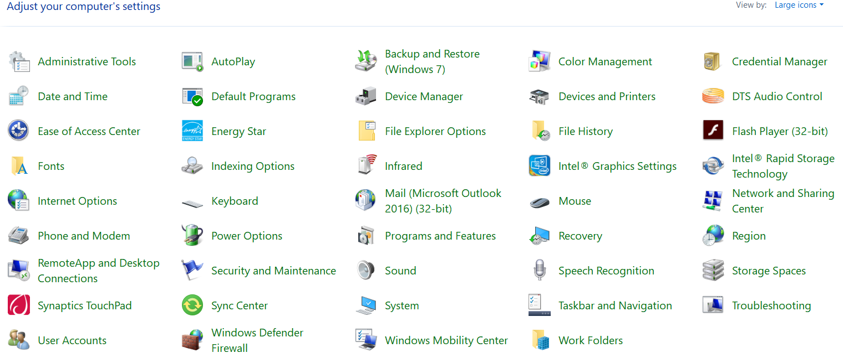
I suspect in Windows 10 there is a way to find those projects, but they created ‘categories’ under settings, which I never liked as well as the small icons in Control Panel.

A tip. If you need to modify something on your computer, just ask Cortana for help. She manages the search bar on the desktop. She’s very talented and generally will take you right where you need to be!
